|  |  |  |  |
| --- | --- | --- | --- |
| **LAB NAME** | Drilling Fluids and Cementing | **LAB NUMBER:** |  |
| **EQUIPMENT NAME:** | Gas Cylinder | **PREPARED BY:** |  |

1. **EQUIPMENT SPECIFICATION**

|  |  |  |  |
| --- | --- | --- | --- |
| **Gas** | **Specifications** | Related image | Safety Risk |
| **N2** | Maximum Pressure: 2,000 psi  Purity: 99.997% | High pressure |

**Definition:** It a cylindrical pressurized vessel that is used to apply pressure for various purposes in research.

1. **NEW CYLINDERS**

When a gas cylinder is received, it shall be checked for the following:

1. A stamped hydrostatic test date within the last five years.
2. A stenciled or labeled identification of its contents (Fig.1)

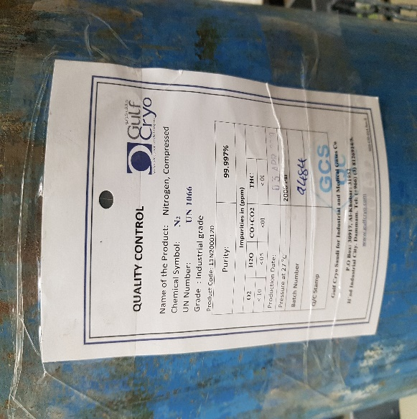

Figure 1: A label of contents on cylinder

1. Make sure cylinder is in acceptable condition.
2. Presence of a valve protection cap as shown in Fig.2

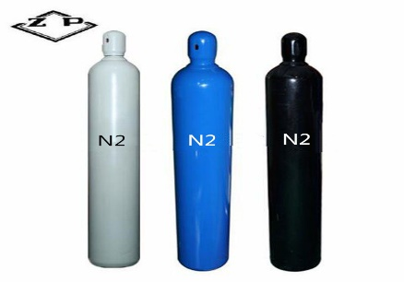

**Cap**

Figure 2: Capped Cylinder

1. Always secure cylinders with chain or cart as shown in Fig.3

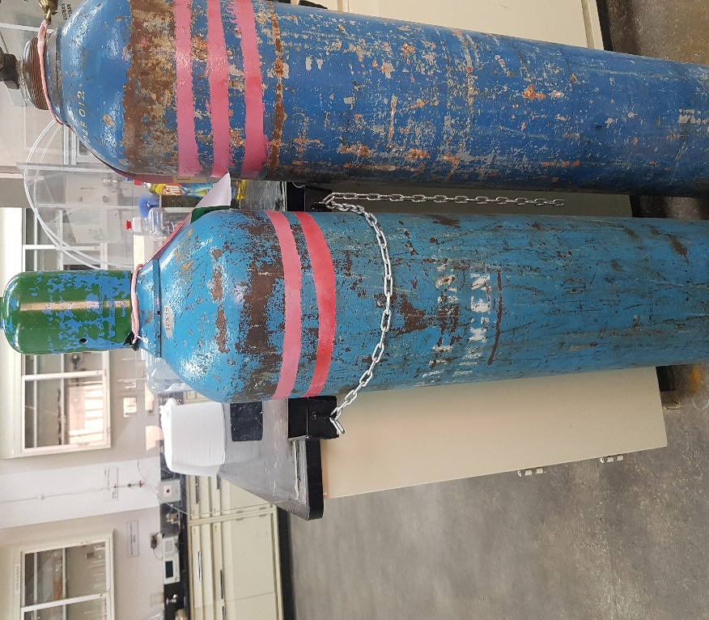

The Cylinder is unchained- Unsafe

The Cylinder is chained-Secured

Figure 3: Chained cylinder vs unchained cylinder

1. Keep cylinders away from radiators and other sources of heat.
2. Do not subject cylinders to temperature extremes.
3. Do not use cylinders as a support, doorstop or coat rack.
4. When the cylinder is not in use, close the valve and relieve the pressure from the regulator.
5. Mark used cylinders “Empty” and never store with other full cylinders.
6. Do not store cylinders where they can become part of an electrical circuit.
7. Do not store cylinders in front of eyewash/emergency shower stations, spill kits or fire extinguishers.
8. Do not lift cylinder by the protective valve cap.
9. Use a hand truck to transport cylinders and never move cylinders from one location to another by manhandling or rolling.
10. **HOW TO CONNECT A REGULATOR**
11. When we need to connect the regulator with cylinder, we need to select the fitting designated by Compressed Gas Association (CGA). The CGA number is written on the gas cylinder valve which is used in choosing the regulator fitting for the cylinder as shown in Fig.4.

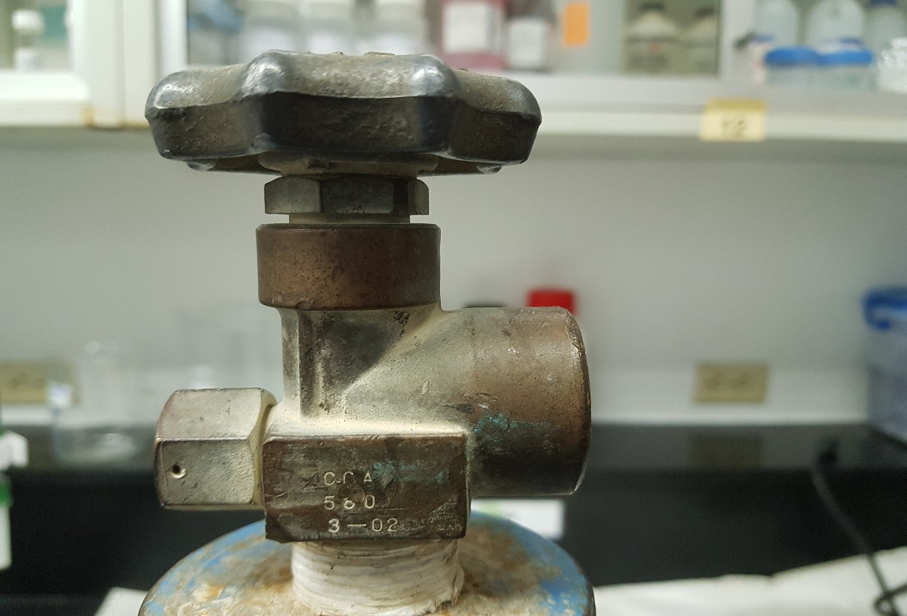

**Cylinder valve**

Figure 4: CGA number written on valve of a cylinder

1. Match this number with the number written on the nut of a regulator as shown in Fig.5.

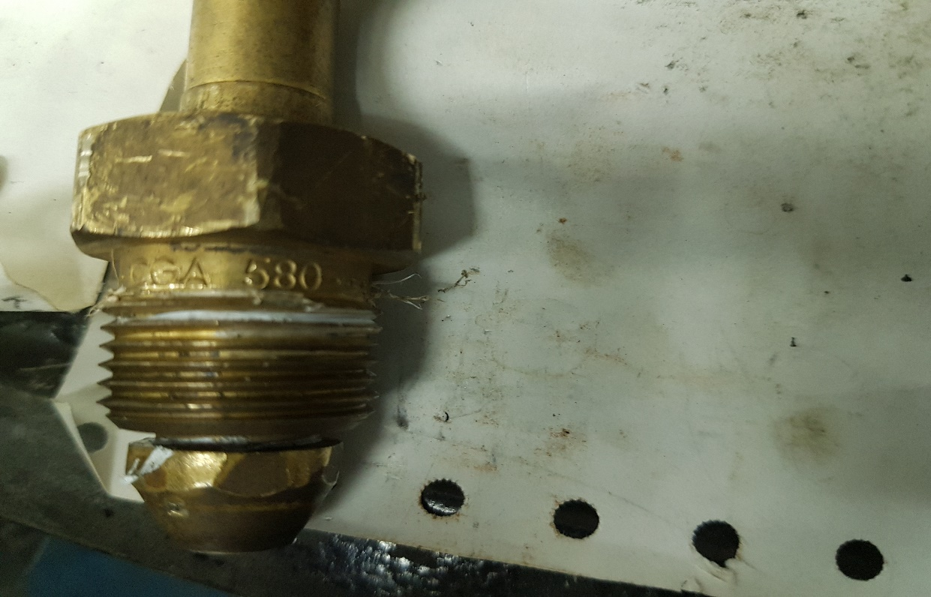

Figure 5: CGA number on regulator nut

1. After matching the numbers, put Teflon tape on the threads of a nut to avoid leakage as shown in Fig.6.

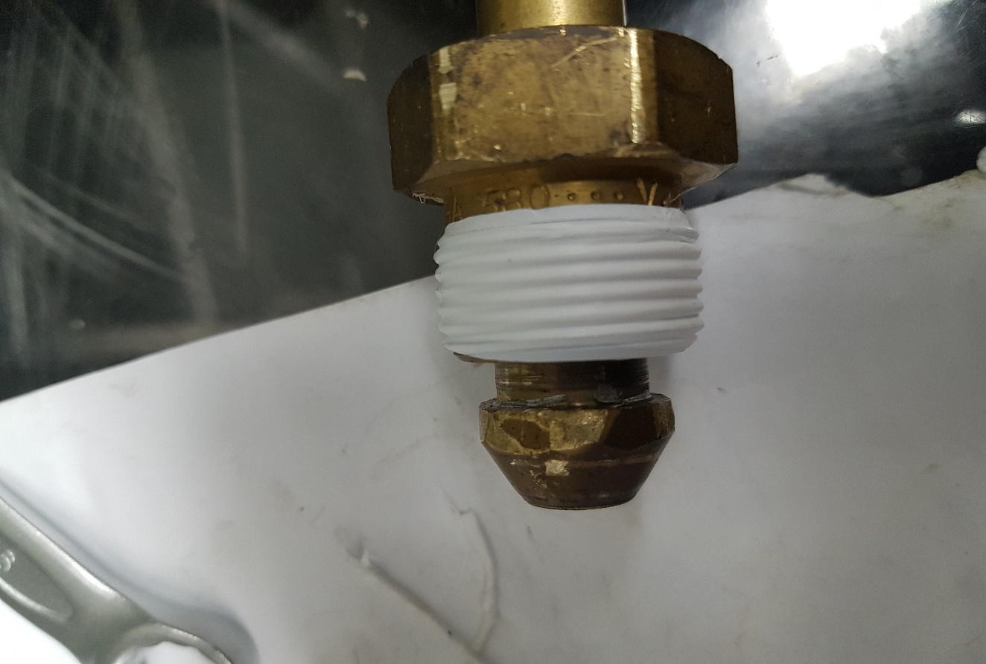

Figure 6: Teflon tape on a regulator nut

1. Connect the regulator with cylinder by rotating in clockwise direction. Before using wrench for tightening the nut, hand tight the regulator nut in female threads of regulator so that thread can be aligned easily. After aligning, use wrench to tight it very well.
2. After tightening the nut, open the cylinder by rotating its valve in anticlockwise direction. To check the leakage, make foam using a sponge and soup and apply on connection. If there is a leakage tight it more otherwise Teflon to be applied once again.
3. There are two gauges on the regulator i.e. First one aligned with nut, shows the pressure inside the cylinder and second one is used to adjust the pressure for instrument supply (See Fig.7).

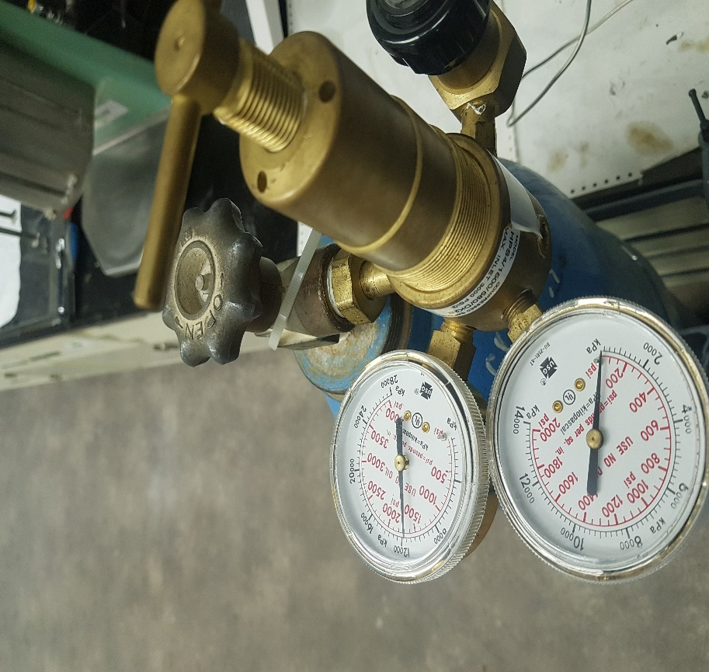

**Valve for adjusting output pressure**

**Output Pressure to Instrument**

**Cylinder Pressure**

Figure 7: Regulator gauges

1. To adjust the required output pressure, rotate the T-screw valve on the regulator clockwise and see the pressure on output pressure regulator (See Fig. 8).

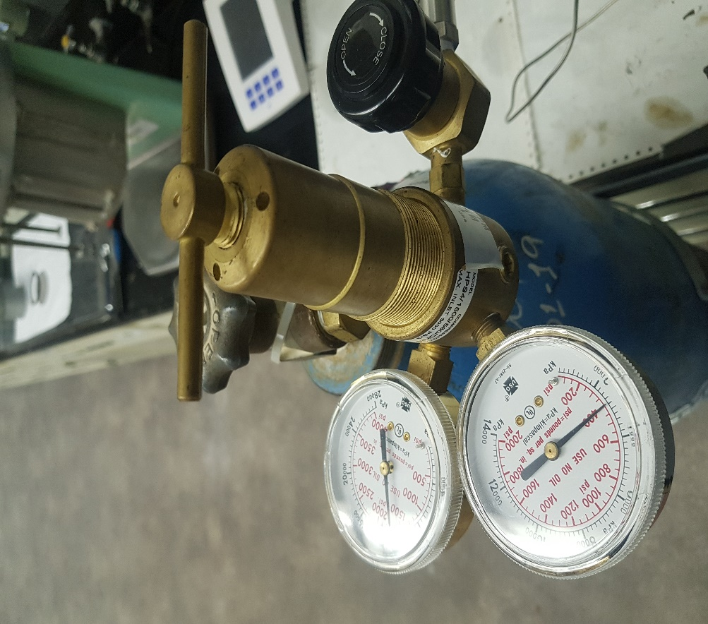

Figure 8: pressure on output gauge

1. After completing the pressure task, close the main supply valve on the cylinder first.
2. Open the output T-screw valve by rotating it anticlockwise.
3. Bleed the pressure from the lines slowly by opening a connection a little bit using a wrench.